Thiamine-Mediated Benzoin Condensation of Furfural

**Reference:** Handout; Chemistry lessons: Carbonyl chemistry, oxidation chemistry, carbon skeleton rearrangements; Green lessons: safer and easier to handle reagents and solvents; Bruice pg. 752-753

**Purpose:** To explore how thiamine affects the formation of furoin from furfural through benzoin condensation reactions

**Table of Reagents:**

|  |  |  |  |  |  |
| --- | --- | --- | --- | --- | --- |
| **Compounds** | **MW** | **Amount** | **BP (°C)** | **MP (°C)** | **Density** |
| Thiamine HCl | 337.26 g/mol | 0.3 g | - | 250 °C | - |
| Ethanol (EtOH) | 46.07 g/mol | 3 mL | 78.37 °C | -114.1 °C | 0.789 g/cm3 |
| Water (H2O) | 18.01 g/mol | - | 100 °C | 0 °C | 1.00 g/cm3 |
| NaOH | 39.997 g/mol | 8.0 g | 1388 °C | 318 °C | 2.13 g/cm3 |
| Furfural | 96.08 g/mol | 0.73 mL | 162 °C | -37 °C | 1.16 g/cm3 |

**Balanced Chemical Equation:**

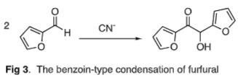

**Mechanism:**

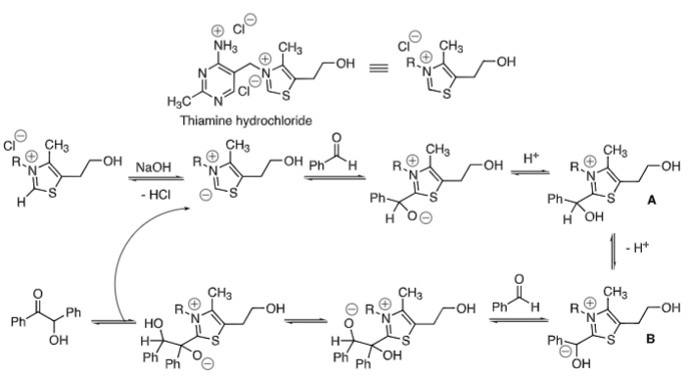

**Safety:**

* Furfural 🡪 toxic; Handle with care
* Sodium Hydroxide 🡪 irritant; Avoid skin & eyes

|  |  |
| --- | --- |
| **Experimental Procedures** | **Data & Observations** |
| **Part I: Reaction**  **1.** Obtain 25 mL round-bottom flask; add stir bar & 0.3 g thiamine HCl in mixture with 0.45 mL water/ 3.0 mL of EtOH   * Mixture should be clear/colorless |  |
| **2.** Dropwise 🡪 add 0.9 mL of solution with 8 g of NaOH in 100 mL of water (already provided)   * Continue to add NaOH until reaction is pale-yellow; if not, add more NaOH | *Observations:* Mixture started to turn pale yellow |
| **3.** Add 0.73 mL of furfural & mix; store in drawer until next lab   * BE SURE TO SEAL THE FLASK!!! |  |
| **Part II: Workup and Purification**  **4.** Cool mixture in ice bath; Add water to cooled mixture to drive remainder of product; Isolate using vacuum filtration   * Record mass of product |  |
| **5.** Recrystallize product using the EtOH |  |
| **Part III: Characterization**  **6.** Record yield, melting point, and IR spectrum of the furoin | *True Melting Point:* 135 °C – 137 °C  *Product Melting Point:* 137 °C  *Product Mass:* 0.58 g |

**Post-lab Questions:**

**1. a)** Our furoin product was a solid, brownish powder and it melted at 137 °C. The true melting point range of pure furoin is between 135 – 137 °C, which matches our product’s melting point signifiying that it is pure furoin, thus it did not experience melting point depression.

**b)** We collected 0.58 g of the crude product as well as the color of our product was a brownish-powder.

$$\% Yield= \frac{Product Obtained}{Theoretical Yield}×100$$

*Obtained:* 0.58 g *Color and State:* Solid, Brownish Powder

* First, we must obtain the theoretical value of our crude product in grams:
$$0.73 mL furfural×\frac{1.16 g Furfural}{1 mL Furfural}×\frac{1 mol Furfural}{96.08 g Furfural}×\frac{1 mol Furoin}{2 mol Furfural}×\frac{192.17 g Furoin}{1 mol Furoin}=0.847 g Furoin$$

* Next, we must use the equation above to get our % Yield:
$$\% Yield=\frac{0.580 g}{0.847 g}×100=68.48\% yield$$

* *We received a 68.48% yield for our product*
* *We received a rather moderately high yield; we did not do the recrystallization step as instructed (cannot calculate the % recovery).*

**2. IR Spectrum of Furoin**

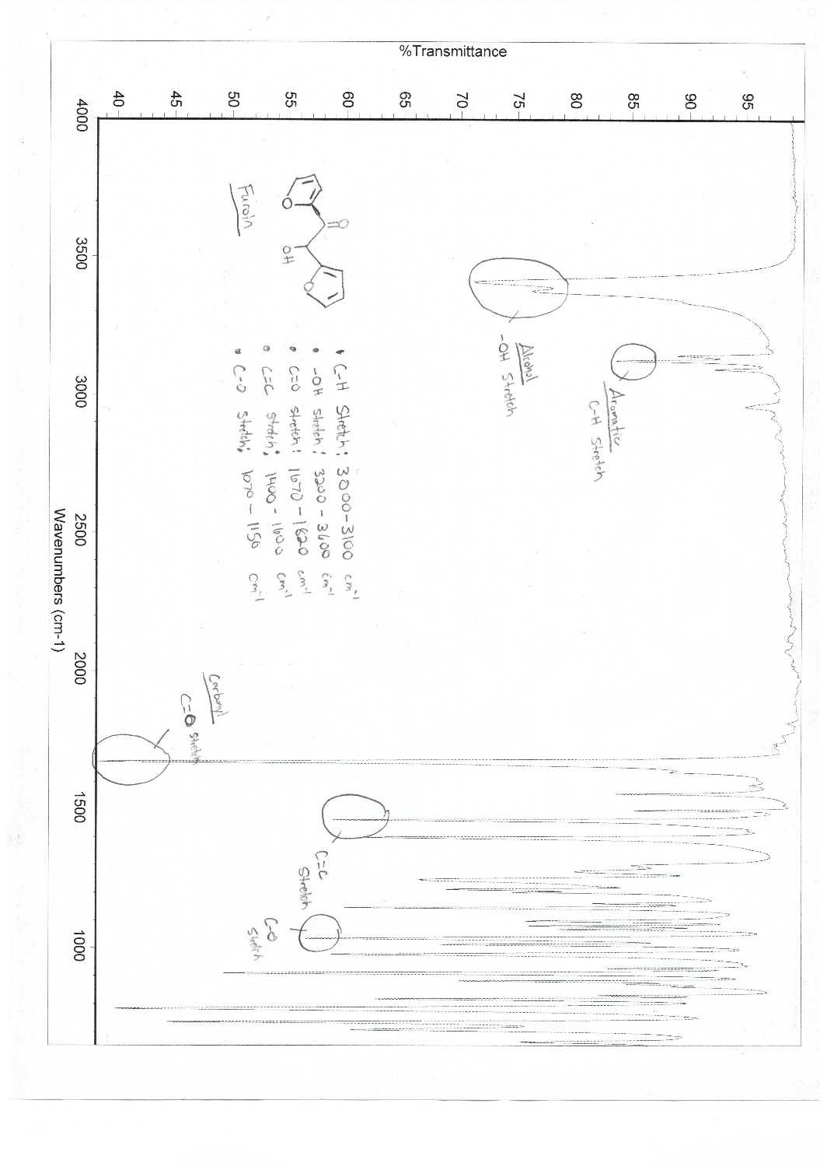

**3.**  **NMR of Fufural and Furoin**

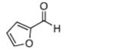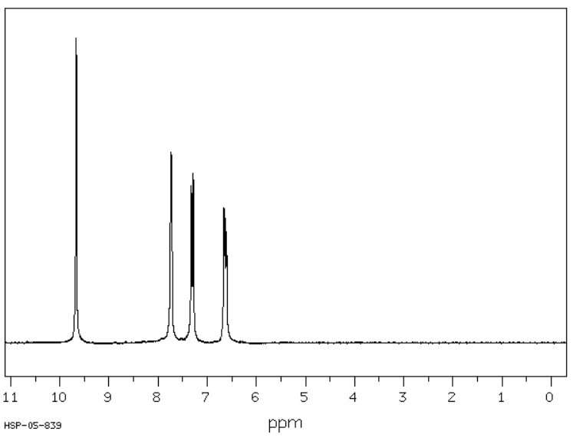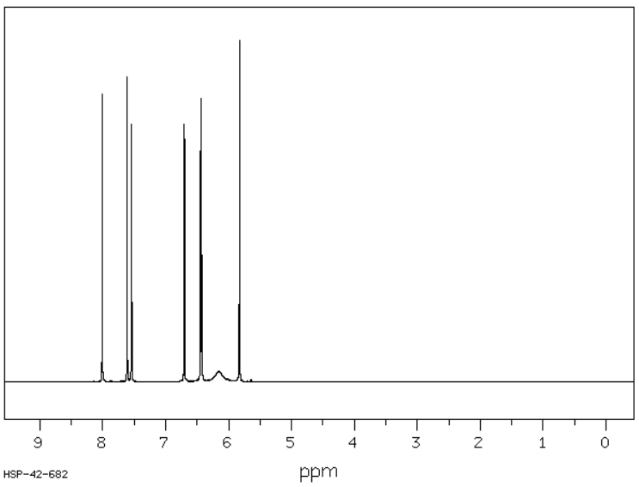

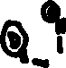

**Furoin 1H NMR**

**Furfural 1H NMR**

**a)** The aldehyde H appears around the 9.8 ppm area on furfural, however, this peak disappears on furoin as the functional group does not exist in furoin.

**b)** It is expected for the Hs on the furan ring to be around 7-8 ppm, which is similar to benzene Hs because both satisfy aromatic properties correlating to the common aromatic Hs shown.

**c)** The broad peak around 6.2 ppm and the peak around 5.9 ppm attribute to the resonance seen in furoin, but not in furfural.

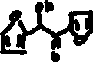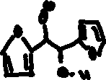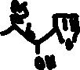

**4. $Atom Economy= \frac{MW of products}{MW of reactants}×100$**

$Atom Economy= \frac{192.15 g }{2×96.08}×100=99.99\% (100\%)$

**5.** The compound is chiral, however, is not “optically active” because it is a racemic mixture (50:50 mix of 2 enantiomers). The mixture contains both R and S configuration, which makes it not optically active as one does not dominate the other.

**6.** My resonance structure supports that the thiazole derivative A is acidic due to the fact that the hydrogen ion (before deprotonation) was the most acidic. However, once the the proton was deprotonated, the ring was stabilized by resonance resulting in carbanion B (charge was moved onto S in the ring).

